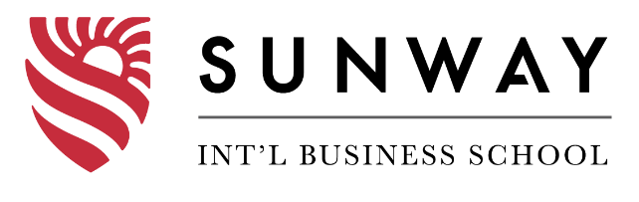

**Programme Name: BCS**

**Course Code: MPU3432**

**Course Name: Badminton**

**Assignment / Lab Sheet / Project / Case Study No/Proposal/Report_1___**

**Date of Submission: 7/19/2020**

**Submitted By: Submitted To:**

**Student Name: Dipesh Tha Shrestha Name: Manish Sir**

**IUKL ID: 041902900028**

**Semester: Second**

**Intake:2019**

**TABLE OF CONTENTS**

**INTRODUCTION** 3

**VISION, MISSION AND OBJECTIVES** 3

**BENEFITS AND WEAKNESSES** 3

**RESULTS** 3

**CONCLUSION** 3

**APPENDIX** 4

# **INTRODUCTION**

The Intra-College Badminton Tournament was held effectively. Occasions and Sports Club of Sunway sorted out and led the competition on second June, 2019, welcoming members and volunteers from all the semesters, both BCS and MBA.

# **VISION, MISSION AND OBJECTIVES**

The principle point of this Badminton Tournament was to advance games at Sunway school, by building heartfelt connection between the understudies and the staffs. We imagined to fabricate sportsmanship, uprightness, prudence, accord and acquaintanceship among the members, volunteers and the staffs through this competition. The competition demonstrated a mode of reward entertainment from work and study for the two understudies and the school.

# **BENEFITS AND WEAKNESSES**

The competition was a flat out progress. All the members and volunteers were truly included for the accomplishment of the competition. The competition gave reward and amusement to the understudies and staffs from work weight and study. It demonstrated productive to make an obligation of acquaintanceship, accord and sportsmanship among the members. This occasion profited physical wellness and improved the confidence of the members.

Lamentably, a portion of the members didn't appear at the competition, because of which changes must be made to the ties. The quantity of volunteers was lesser than anticipated, so the executives was troublesome. Be that as it may, in spite of the difficulties, all conveyed an uplifting disposition for progress.

# **RESULTS**

Around 125, including understudies and staffs, took an interest in the competition. The competition was very serious and capricious. Members propelled themselves past the cutoff to win the competition. However, toward the end, Bibek Ghimire (fourth Semester) developed as the champ of the young men's opposition. Peter Karki, from third Semester, completed as second place. Then again, in the young ladies' opposition, Nisha Baruwal (Second Semester) stowed the gold. Amita Adhikari (Fourth Semester) held next in line.

# **CONCLUSION**

Students and staffs were genuinely involved in the event. First, Third, Fourth semester bagged one medals (gold, silvers, gold, silver) respectively. Despite some challenges, all participants were immensely supportive. The tournament was a success.

# **APPENDIX**

